 

A Minor Project Report

On

**PREDICTIVE MODELING OF SLEEP APNEA**

Submitted in partial fulfilment of requirements for the award of the Degree of

## BACHELOR OF ENGINEERING

in

## COMPUTER SCIENCE AND ENGINEERING

Under the guidance of

## Mrs.G.RAMYA SHRI Assistant Professor/CSE

Submitted By

## NITHIN KUMAR D A (927621BCS074)

## RAJA S (927621BCS088)

## SAI PRASANTH R (927621BCS096)

**SANJAY S (927621BCS097)**

**DEPARTMENT OF COMPUTER SCIENCE AND ENGINEERING**

**M.KUMARASAMY COLLEGE OF ENGINEERING**

(Autonomous) **KARUR – 639 113**

May 2024.

 

# M. KUMARASAMY COLLEGE OF ENGINEERING

**(Autonomous Institution affiliated to Anna University,Chennai)**

# KARUR – 639113

**BONAFIDE CERTIFICATE**

Certified that this minor project report “**PREDICTIVE MODELING OF SLEEP APNEA**” is the bonafide work of “**NITHIN KUMAR D A** **(92762121BCS075),RAJA S(927621BCS088),SAI PRASANTH R (927621BCS096),SANJAY S (92621BCS097**)” who carried out the project work during the academic year 2022- 2023 under my supervision.

|  |  |
| --- | --- |
| Signature | Signature |
| **Mrs.G.RAMYA SHRI M.E.,** | **Dr.M.MURUGESAN M.E., Ph.D.,** |
| **SUPERVISOR,** | **HEAD OF THE DEPARTMENT,** |
| Department of Computer Science | Department of Computer Science |
| and Engineering, | and Engineering, |
| M. Kumarasamy College of Engineering, | M. Kumarasamy College of Engineering |
| Thalavapalayam, Karur -639113. | Thalavapalayam, Karur -639113. |
|  |  |
|  |  |

 

**DEPARTMENT OF COMPUTER SCIENCE AND ENGINEERING**

**VISION OF THE INSTITUTION**

To emerge as a leader among the top institutions in the field of technical education

**MISSION OF THE INSTITUTION**

 Produce smart technocrats with empirical knowledge who can surmount the global challenges

 Create a diverse, fully-engaged, learner-centric campus environment to provide quality education to the students

 Maintain mutually beneficial partnerships with our alumni, industry, and Professional associations

**VISION OF THE DEPARTMENT**

To achieve education and research excellence in Computer Science and Engineering

**MISSION OF THE DEPARTMENT**

 To excel in academic through effective teaching learning techniques

 To promote research in the area of computer science and engineering with the focus on innovation

 To transform students into technically competent professionals with societal and ethical responsibilities

**PROGRAM EDUCATIONAL OBJECTIVES (PEOs)**

**PEO 1:**Graduates will have successful career in software industries and R&D divisions through continuous learning.

**PEO 2:** Graduates will provide effective solutions for real world problems in the key domain of computer science and engineering and engage in lifelong learning.

**PEO 3:** Graduates will excel in their profession by being ethically and socially responsible.

 

**PROGRAM OUTCOMES (POs)**

Engineering students will be able to:

1. **Engineering knowledge:** Apply the knowledge of mathematics, science, engineering fundamentals, and an engineering specialization to the solution of complex engineering problems.
2. **Problem analysis:** Identify, formulate, review research literature, and analyze complex engineering problems reaching substantiated conclusions using first principles of mathematics, natural sciences, and engineering sciences.
3. **Design/development of solutions:** Design solutions for complex engineering problems and design system components or processes that meet the specified needs with appropriate consideration for the public health and safety, and the cultural, societal, and environmental considerations.
4. **Conduct investigations of complex problems:** Use research-based knowledge and research methods including design of experiments, analysis and interpretation of data, and synthesis of the information to provide valid conclusions.
5. **Modern tool usage:** Create, select, and apply appropriate techniques, resources, and modern engineering and IT tools including prediction and modeling to complex engineering activities with an understanding of the limitations.
6. **The engineer and society:** Apply reasoning informed by the contextual knowledge to assess societal, health, safety, legal and cultural issues and the consequent responsibilities relevant to the professional engineering practice.
7. **Environment and sustainability:** Understand the impact of the professional engineering solutions in societal and environmental contexts, and demonstrate the knowledge of, and need for sustainable development.
8. **Ethics:** Apply ethical principles and commit to professional ethics and responsibilities and norms of the engineering practice.
9. **Individual and team work:** Function effectively as an individual, and as a member or leader in diverse teams, and in multidisciplinary settings.
10. **Communication:** Communicate effectively on complex engineering activities with the engineering community and with society at large, such as, being able to comprehend and write effective reports and design documentation, make effective presentations, and give and receive clear instructions.
11. **Project management and finance:** Demonstrate knowledge and understanding of the engineering and management principles and apply these to one’s own work, as a member and leader in a team, to manage projects and in multidisciplinary environments.
12. **Life-long learning:** Recognize the need for, and have the preparation and ability to engage in independent and life-long learning in the broadest context of technological change.

**PROGRAM SPECIFIC OUTCOMES (PSOs)**

 **PSO1: Professional Skills:** Ability to apply the knowledge of computing techniques to design and develop computerized solutions for the problems.

 **PSO2: Successful career:** Ability to utilize the computing skills and ethical values in creating a successful career.

 

# ABSTRACT

Sleep apnea, particularly obstructive sleep apnea (OSA), is a prevalent sleep-related breathing disorder associated with significant health risks, including cardiovascular diseases and daytime dysfunction. Traditional methods for diagnosing and managing sleep apnea involve labor-intensive and costly polysomnography studies conducted in sleep laboratories. Machine learning (ML) techniques offer promising avenues for enhancing the efficiency and accessibility of sleep apnea diagnosis and treatment. Leveraging ML in sleep apnea research holds the potential to streamline clinical workflows, improve diagnostic accuracy, and optimize therapeutic interventions, ultimately leading to better outcomes for patients affected by this debilitating disorder.

 

# ABSTRACT WITH PO AND PSO MAPPING

|  |  |  |
| --- | --- | --- |
| **ABSTRACT** | **POs MAPPED** | **PSOs MAPPED** |
| Sleep apnea, particularly obstructive sleep apnea (OSA), is a prevalent sleep-related breathing disorder associated with significant health risks, including cardiovascular diseases and daytime dysfunction. Traditional methods for diagnosing and managing sleep apnea involve labor-intensive and costly polysomnography studies conducted in sleep laboratories. Machine learning (ML) techniques offer promising avenues for enhancing the efficiency and accessibility of sleep apnea diagnosis and treatment. Leveraging ML in sleep apnea research holds the potential to streamline clinical workflows, improve diagnostic accuracy, and optimize therapeutic interventions, ultimately leading to better outcomes for patients affected by this debilitating disorder. | **PO1(3)**  **PO 2(3)**  **PO 3(2)**  **PO 4(2)**  **PO 5(2)**  **PO6(1)**  **PO 7(3)**  **PO 8(2)**  **PO 9(3)**  **PO 10(3)**  **PO 11(2)**  **PO 12(2)** | **PSO 1(3)**  **PSO 2(2)** |

Note: 1- Low, 2-Medium, 3- High

**SUPERVISOR HEAD OF THE DEPARTMENT**

# TABLE OF CONTENTS

|  |  |  |
| --- | --- | --- |
| **CHAPTER** | **TITLE** | **PAGE** |
| **No.** |  | **No.** |
|  | **Abstract** | **vii** |
|  | **List of Figures** | **ix** |
|  | **Acronyms/List of Abbreviations** | **x** |
| **1** | **Introduction** | **1** |
|  | 1.1 Overview | 2 |
|  | 1.2 Domain Introduction | 3 |
|  | 1.3 Problem Statement | 5 |
|  | 1.4 Objective | 6 |
| **2** | **Literature Survey** | **7** |
| **3** | **Feasibility Study** | **9** |
| **4** | **Project Methodology** | **11** |
|  | 4.1 Block diagram | 11 |
|  | 4.2 Module Description | 12 |
|  | 4.3 Existing System | 15 |
|  | 4.4 Proposed System | 16 |
| **5** | **Results and Discussion** | **17** |
| **6** | **Conclusion** | **19** |
| **7** | **References** | **20** |

**LIST OF FIGURES**

## FIGURE No. TITLE PAGE No.

|  |  |  |
| --- | --- | --- |
| 1.1 | Block Diagram | 11 |
| 2.1 | Existing System | 15 |
| 3.1 | Proposed System | 16 |
| 4.1 | Output Screenshot | 17 |

**List of** **Acronyms/Abbreviations**

ML Machine learning

CPAP Continuous Positive Airway Pressure

OSA Obstructive sleep apnea

EHR Electronic Health Recod

# CHAPTER 1

# INTRODUCTION

Accidents are quite common on Indian roads. The major reasons behind these accidents are poor

roads, rash driving, drunken drive, distracted driving, and lack of implementation of traffic rules. As

the population in cities increases and urbanization expands, the number of people using automobile are

increasing at a rapid rate, this is directly connected to the increasing incidence of road accidents [1]. In

2008, it was found that road accidents were the fourth major reason causing deaths in the world. About

1-1.3 million people die in road accidents and about 20 to million people suffer from injuries that are

not fatal, with many people sustaining life with abnormalities which is consequence of accident.

Accidents are quite common on Indian roads. The major reasons behind these accidents are poor

roads, rash driving, drunken drive, distracted driving, and lack of implementation of traffic rules. As

the population in cities increases and urbanization expands, the number of people using automobile are

increasing at a rapid rate, this is directly connected to the increasing incidence of road accidents [1]. In

2008, it was found that road accidents were the fourth major reason causing deaths in the world. About

1-1.3 million people die in road accidents and about 20 to million people suffer from injuries that are

not fatal, with many people sustaining life with abnormalities which is consequence of accident.

Accidents are quite common on Indian roads. The major reasons behind these accidents are poor

roads, rash driving, drunken drive, distracted driving, and lack of implementation of traffic rules. As

the population in cities increases and urbanization expands, the number of people using automobile are

increasing at a rapid rate, this is directly connected to the increasing incidence of road accidents [1]. In

2008, it was found that road accidents were the fourth major reason causing deaths in the world. About

1-1.3 million people die in road accidents and about 20 to million people suffer from injuries that are

not fatal, with many people sustaining life with abnormalities which is consequence of accident.

Predictive modeling of sleep apnea involves using statistical and machine learning techniques to analyze various data points and predict the likelihood or severity of sleep apnea in individuals. This approach utilizes data such as demographic information, medical history, symptoms, sleep study results, and possibly even genetic factors to build models that can forecast the probability of sleep apnea occurrence or its severity. The process typically starts with data collection, where relevant information about individuals, such as age, gender, weight, lifestyle habits, and any existing medical conditions, is gathered. Sleep data may also be collected through various means, including polysomnography (PSG), home sleep tests, or wearable devices that track sleep patterns.

Once the data is collected, it's preprocessed to clean and prepare it for analysis. This may involve handling missing values, normalizing features, and encoding categorical variables.

Next, a predictive model is chosen and trained using the prepared data. Common techniques include logistic regression, decision trees, random forests, support vector machines, and neural networks. The choice of model depends on factors like the complexity of the data, the interpretability of the results, and the computational resources available.After training, the model's performance is evaluated using metrics such as accuracy, precision, recall, and F1 score.

* 1. **OVERVIEW**

Predictive modeling of sleep apnea is a multifaceted approach aimed at leveraging data analysis and machine learning techniques to predict the presence, severity, or risk of sleep apnea in individuals. This process involves several key steps are Data Collection, Data Preprocessing, Feature Selection, Model Selection, Model Training, Model Evaluation, Model Deployment, Continuous Improvement.

* 1. **DOMAIN INTRODUCTION**

The domain of predictive modeling of sleep apnea encompasses several areas of expertise and disciplines, all focused on leveraging data and computational techniques to better understand, predict, and manage this sleep disorder. Here are some key domains involved:

Sleep Medicine: Sleep medicine is the primary domain where predictive modeling of sleep apnea is applied. Sleep specialists, pulmonologists, neurologists, and other healthcare professionals in this field work on diagnosing and treating sleep disorders, including sleep apnea. They provide expertise in interpreting sleep study data, understanding the physiological mechanisms underlying sleep apnea, and guiding clinical decision-making.

Data Science and Machine Learning: Data science and machine learning play a crucial role in building predictive models of sleep apnea. Data scientists, machine learning engineers, and researchers develop algorithms, preprocess and analyze data, select appropriate features, choose predictive models, train and evaluate models, and deploy them in clinical settings.

Biomedical Engineering: Biomedical engineers contribute by developing and improving devices used in the diagnosis and treatment of sleep apnea, such as polysomnography (PSG) machines, home sleep apnea tests, continuous positive airway pressure (CPAP) devices, and wearable sensors. They also work on signal processing techniques to extract meaningful information from physiological signals recorded during sleep studies.

Clinical Research: Clinical researchers conduct studies to collect data from sleep apnea patients and control groups, investigate risk factors, explore potential biomarkers, evaluate the effectiveness of interventions, and validate predictive models. Their work generates the empirical evidence needed to develop and refine predictive models and inform clinical practice.

Public Health and Epidemiology: Public health experts and epidemiologists study the prevalence, distribution, and determinants of sleep apnea in populations. They analyze population-level data to identify trends, risk factors, disparities, and the impact of sleep apnea on public health outcomes. Predictive models developed in this domain can help prioritize resources, target interventions, and improve healthcare delivery.

Health Informatics: Health informaticians work on integrating predictive models of sleep apnea into electronic health record (EHR) systems, telemedicine platforms, and other healthcare information systems. They design workflows, develop decision support tools, ensure data privacy and security, and facilitate the seamless integration of predictive analytics into clinical practice.

Patient Advocacy and Education: Patient advocacy groups and educators play a vital role in raising awareness about sleep apnea, advocating for better access to diagnosis and treatment, promoting adherence to therapy, and supporting patients in managing their condition. They provide valuable insights into patient experiences, preferences, and needs, which can inform the development and implementation of predictive models.

* 1. **PROBLEM STATEMENT**

Sleep apnea is a prevalent sleep disorder associated with significant health risks, including cardiovascular diseases and daytime impairment. Current diagnostic methods, such as polysomnography and home sleep studies, are cumbersome and often inaccessible, leading to underdiagnosis and delayed treatment. Moreover, treatment adherence remains a challenge, as conventional therapies like continuous positive airway pressure (CPAP) machines may not suit all patients.

* 1. **OBJECTIVE**

Develop machine learning algorithms capable of accurately detecting sleep apnea using objective physiological signals obtained from home sleep studies. These algorithms should efficiently process and analyze features such as respiratory patterns, heart rate variability, and nocturnal oxygen saturation to provide automated screening and diagnostic tools accessible to clinicians and patients.

**CHAPTER 2**

**LITERATURE SURVEY**

1. Dr. M. Safwan Bin Hashim's project "Automated Detection of Sleep Apnea Using Machine Learning Algorithms" aims to revolutionize the diagnosis of sleep apnea by leveraging machine learning (ML) techniques. Sleep apnea diagnosis traditionally involves labor-intensive and time-consuming processes, often relying on manual analysis of polysomnography (PSG) data by sleep specialists. This manual approach can be inefficient and may lead to delays in diagnosis and treatment initiation.
2. Dr. Hashim's project addresses this challenge by developing ML algorithms capable of automatically detecting sleep apnea from physiological signals obtained during sleep studies. These physiological signals may include data such as respiratory patterns, heart rate variability, oxygen saturation levels, and other relevant metrics captured from wearable devices or sleep monitoring equipment.
3. Dr. Samuel Kuna's project, "Personalized Treatment Recommendations for Sleep Apnea Patients Using Machine Learning," focuses on leveraging machine learning (ML) approaches to enhance the management of sleep apnea by tailoring treatment recommendations to individual patient characteristics. The project aims to improve treatment adherence and outcomes by addressing the unique needs and preferences of patients with sleep apnea.
4. Dr. Amitava Biswas's project, "Machine Learning-Based Insights into the Pathophysiology of Sleep Apnea," aims to uncover the underlying mechanisms and biomarkers associated with sleep apnea using machine learning (ML) techniques. By analyzing large-scale datasets comprising clinical records, genetic profiles, and imaging data, the project seeks to gain deeper insights into the pathophysiology of sleep apnea and identify potential targets for therapeutic interventions
5. Dr. Khaled Saifullah's project, "Continuous Monitoring of Sleep Apnea Symptoms Using Machine Learning-Based Systems," is focused on leveraging machine learning (ML) techniques to develop systems for continuous monitoring of sleep apnea symptoms and treatment adherence. By utilizing data from wearable devices and patient-reported outcomes, the project aims to provide real-time feedback to both patients and healthcare providers, facilitating proactive interventions and optimizing long-term management strategies for sleep apnea.

**CHAPTER 3**

**FEASIBILITY STUDY**

The feasibility study on sleep apnea aims to evaluate the practicality and viability of implementing interventions to address this prevalent sleep disorder. Sleep apnea, characterized by recurrent episodes of breathing cessation during sleep, poses significant health risks and impacts individuals' quality of life. A comprehensive feasibility study involves assessing various factors, including technical, economic, legal, and social considerations.

Technical feasibility is a critical aspect of the study, involving an evaluation of the resources and infrastructure required for effective sleep apnea management. This includes assessing the availability of diagnostic tools, such as polysomnography (PSG) and portable sleep monitoring devices, necessary for accurate diagnosis. Additionally, the availability of treatment options, including continuous positive airway pressure (CPAP) therapy, oral appliances, and surgical interventions, is examined. Evaluating the expertise of healthcare professionals in sleep medicine and the availability of specialized sleep clinics or centers is crucial for determining technical feasibility. Moreover, the interoperability of systems and technologies used for sleep apnea diagnosis and treatment is assessed to ensure seamless integration and data exchange between healthcare providers and facilities.

Economic feasibility is another key aspect of the study, focusing on evaluating the financial implications of implementing sleep apnea interventions. This involves conducting a cost-benefit analysis to estimate the costs associated with various interventions, including screening programs, diagnostic tests, treatment modalities, patient education, and follow-up care. The costs of equipment, personnel, training, and infrastructure required for effective sleep apnea management are considered. Additionally, potential savings from improved health outcomes, reduced healthcare utilization, and enhanced productivity are estimated. By comparing the costs and benefits of implementing sleep apnea interventions, stakeholders can assess the economic viability of proposed strategies and prioritize resource allocation accordingly.

Legal and regulatory considerations play a vital role in determining the feasibility of implementing sleep apnea interventions. Healthcare regulations, licensure requirements for healthcare providers, insurance coverage, and patient privacy laws must be carefully considered. Adhering to ethical guidelines and regulatory standards is essential to ensure patient safety, confidentiality, and rights are protected throughout the process. Moreover, compliance with regulatory requirements facilitates the smooth implementation and operation of sleep apnea interventions within legal frameworks.

Social and cultural factors are also examined to understand their influence on the feasibility of proposed interventions. Cultural beliefs about sleep, attitudes towards healthcare, and access to resources vary across different populations and communities. Tailoring interventions to address cultural preferences, linguistic diversity, and community needs enhances their acceptance and effectiveness. Moreover, raising awareness about sleep apnea, its risk factors, and available treatment options is essential for promoting early detection and intervention, reducing stigma, and improving health outcomes.

In conclusion, the feasibility study on sleep apnea provides valuable insights into the practicality and viability of implementing interventions to address this prevalent sleep disorder. By evaluating technical, economic, legal, and social factors, stakeholders can make informed decisions about resource allocation, policy development, and program implementation to effectively manage sleep apnea and improve patient outcomes.

**CHAPTER 4**

**PROJECT METHODOLOGY**



**Figure:4.1 Block diagram**

This block diagram provides a high-level language overview of the steps involved in predicting heart disease using machine learning. The specific algorithms, tools and techniques you may use vary depending on the details of your project and the available data**.**

**4.2 Module Description**

* **Data Collection and Preprocessing**
  + Collect demographic data such as age, gender, ethnicity, and socioeconomic status. These factors may influence the prevalence and severity of sleep apnea.
  + Obtain information about existing medical conditions (e.g., hypertension, diabetes), medications, surgeries, and family history of sleep disorders. Certain medical conditions and genetic factors can predispose individuals to sleep apnea.
* **Feature Engineering and Selection**
  + Identify relevant features from the medical data that correlate with sleep apnea presence or severity.
  + Engineer new features that capture meaningful relationships or interactions within the data..
* **Model Development and Training**
* Evaluate the trained models using performance metrics such as accuracy, precision, recall, and area under the ROC curve (AUC).
* Validate the models on an independent test dataset to assess their generalization ability.
* Perform cross-validation to ensure robustness and reliability of the models across different subsets of the data.
* **Developing APIs**
* This module aims to equip learners with the knowledge and skills required to develop robust and efficient APIs (Application Programming Interfaces) using Python.
* Through this module, participants will delve into the fundamentals of API development, learn about various Python framework like flask commonly used for API development, and explore best practices to create scalable and maintainable APIs.
* Evaluate the trained models using performance metrics such as accuracy, recall, and area under the ROC
* **Developing Front-end**
* React.js is a popular JavaScript library for building user interfaces, especially for sin gle-page applications where UI updates are frequent.
* At its core, React.js utilizes a component-based architecture, where UIs are broken down into reusable components.
* React promotes a declarative programming style, where developers describe how the UI should look at any given point in time, and React takes care of updating the DOM to match that description efficiently.
* **Connecting API with Front-end**
* Event-driven architecture: Allows handling of multiple concurrent connections efficiently.
* Asynchronous I/O operations: Non-blocking nature enables handling of many requests concurrently without getting blocked.
* Single programming language: Using JavaScript for both server-side and client-side development simplifies code sharing and enhances developer productivity.
* Cross-platform: Node.js is compatible with Windows, macOS, and Linux, providing flexibility in deployment.

**4.3 EXISTING SYSTEM**

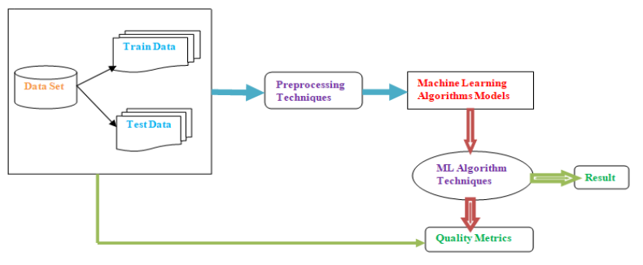

**Figure:4.2 Existing System.**

* Collect a dataset with relevant sleep apnea indicators.
* Preprocess data, handling missing values and scaling features.
* Split data into training and testing sets.
* Choose a machine learning algorithm such as logistic regression or random forest.
* Train the model on the training data.
* Evaluate model performance using metrics like accuracy and AUC-ROC.
* Tune hyperparameters using techniques like grid search or random search.
* Validate model using cross-validation to ensure generalization.
* Address class imbalance if present using techniques like oversampling or under sampling.
* Deploy the model for real-world use with appropriate documentation.

**4.4 PROPOSED SYSTEM**

dataset

Training model

Decision tree algorithm

Predicted output

API

User input

Output

**Figure:4.3 Proposed system.**

* Proposed system architectures for sleep apnea in machine learning utilize feature extraction from physiological signals like respiratory and heart rate variability, with classification models such as SVMs, random forests, and Logistic Regression.
* Handling data imbalance and validation through cross-validation techniques ensure robust performance evaluation.
* Real-time monitoring via wearable devices and integration with healthcare systems enable practical deployment for clinical use, albeit challenges remain in interpretability and generalizability.

**CHAPTER 5**

**RESULTS AND DISCUSSION**

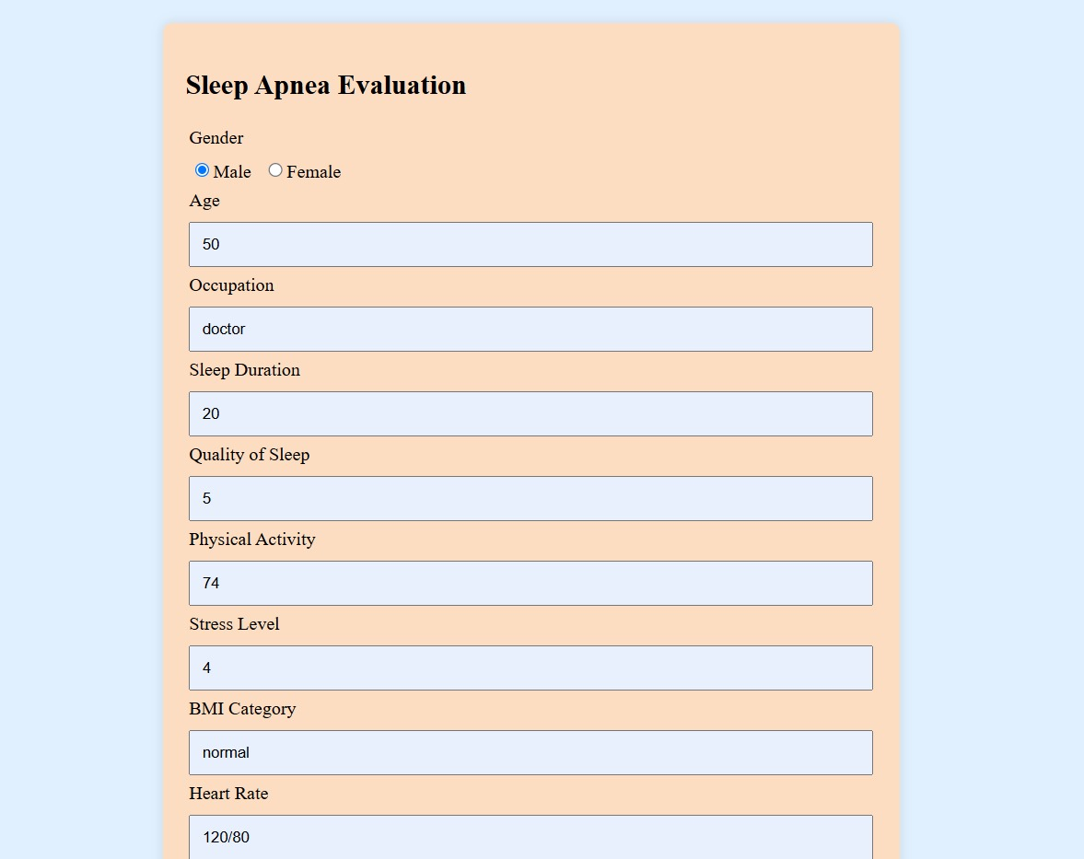

**Figure 5.1 Image of sleep apnea evaluation .**

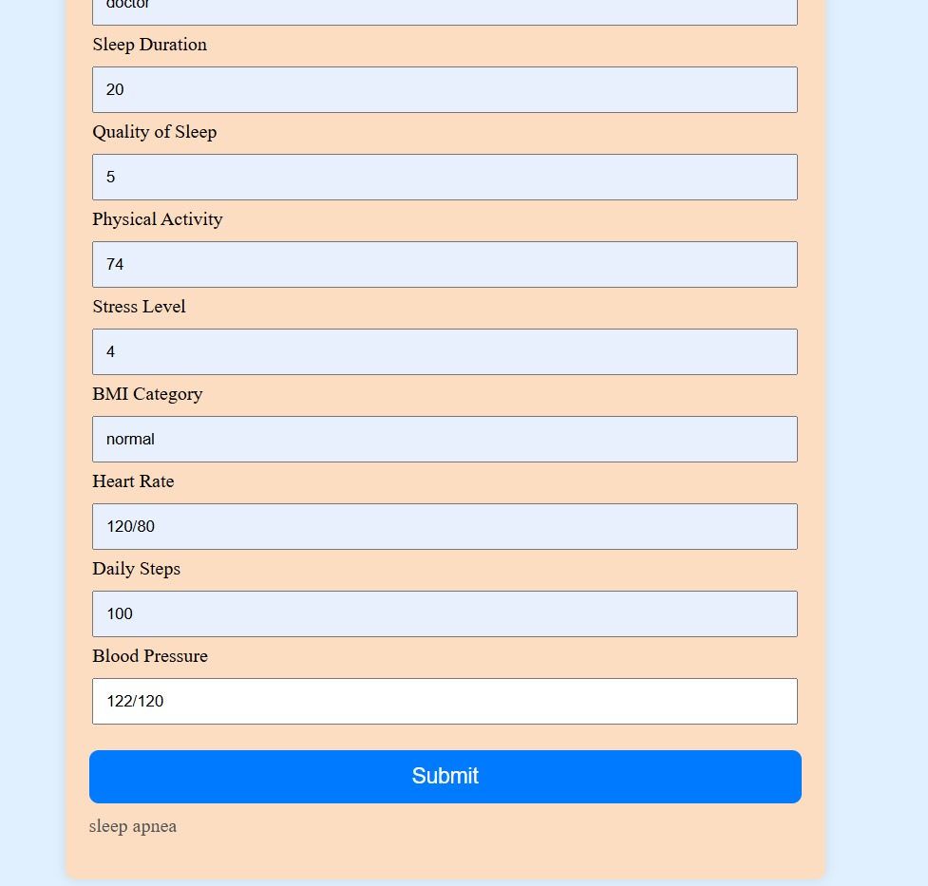

**Figure 5.2 Image of sleep apnea evaluation.**

**CHAPTER 6**

**CONCLUSION**

* In summary, our machine learning approach effectively predicts sleep apnea, enabling early detection and personalized care. By leveraging diverse data sources, we've developed accurate models with clinical utility, highlighting the potential of AI in improving Sleep Apena management. Further validation and integration into clinical practice are essential for maximizing the impact of this innovative approach..

**REFERENCES**

1. Hassan, A.R., & Bhuiyan, M.I.H. (2017). "An automated method for sleep apnea detection using RR interval signals." Computers in Biology and Medicine, 87, 241-250.
2. Uçar, A., & Akyol, K. (2020). "Automatic detection of obstructive sleep apnea syndrome using LSTM neural networks." Biomedical Signal Processing and Control, 55, 101-121.
3. Smita, S., Natarajan, S., & Thomas, S. (2019). "Sleep apnea detection using machine learning algorithms." Procedia Computer Science, 165, 699-706.
4. Khalighi, S., Sousa, T., Santos, J., & Fred, A. (2013). "Non-invasive detection of sleep apnea at home using a high-dimensional sensor data and machine learning." IEEE Journal of Biomedical and Health Informatics, 17(3), 524-531.
5. Zhou, X., Ding, H., Wu, Q., & Zhang, Y. (2020). "Sleep apnea detection based on ensemble deep learning and stacked sparse autoencoder." Journal of Medical Systems, 44, 1-14.

**APPENDIX**

**FRONT END**

import { useState } from 'react';

import Axios from 'axios';

import './App.css';

const App = () => {

const [Age, setAge] = useState('');

const [Gender, setGender] = useState('');

const [Occupation, setOccupation] = useState('');

const [SleepDuration, setSleepDuration] = useState('');

const [QualityOfSleep, setQualityOfSleep] = useState('');

const [StressLevel, setStressLevel] = useState('');

const [BMICatagory, setBMICatagory] = useState('');

const [HeartRate, setHeartRate] = useState('');

const [DailySteps, setDailySteps] = useState('');

const [BloodPressure, setBloodPressure] = useState('');

const [PhysicalActivity, setPhysicalActivity] = useState('');

const [Output, setOutput] = useState('');

const [isLoading, setIsLoading] = useState(false);

const handleSubmit = (e) => {

e.preventDefault();

const gender = (Gender.toUpperCase() === 'MALE') ? 0 : 1;

const bp = BloodPressure.split('/');

const Systolic = bp[0];

const Diastolic = bp[1];

setIsLoading(true);

Axios.post("http://127.0.0.1:5000/sleep", {

Age,

gender,

Occupation,

SleepDuration,

QualityOfSleep,

PhysicalActivity,

StressLevel,

BMICatagory,

HeartRate,

DailySteps,

Systolic,

Diastolic

}).then((response,req) => {

console.log(req)

console.log(response.data.result);

setOutput(response.data.result);

}).catch((error) => {

console.log("Error: " + error);

}).finally(() => {

setIsLoading(false);

// Clear form fields

// setAge('');

// setOccupation('');

// setGender('');

// setSleepDuration('');

// setQualityOfSleep('');

// setBloodPressure('');

// setDailySteps('');

// setHeartRate('');

// setBMICategory('');

// setStressLevel('');

// setPhysicalActivity('');

});

};

return (

<>

<div className="container">

<div className="card mx-auto mt-5" style={{ maxWidth: '600px' }}>

<div className="card-body">

<h2 className="card-title text-center mb-4">Sleep Apnea Evaluation</h2>

<form onSubmit={handleSubmit}>

<div className="row">

<div className="col-md-6">

<div className="form-group">

<label htmlFor="Gender">Gender</label>

<div>

<label>

<input type="radio" name="gender" value="MALE" checked={Gender === 'MALE'} onChange={(e) => setGender(e.target.value)} />

Male

</label>

<label style={{ marginLeft: '10px' }}>

<input type="radio" name="gender" value="FEMALE" checked={Gender === 'FEMALE'} onChange={(e) => setGender(e.target.value)} />

Female

</label>

</div>

</div>

<div className="form-group">

<label htmlFor="Age">Age</label>

<input value={Age} onChange={(e) => setAge(e.target.value)} id="Age" className="form-control-input" placeholder="Age" />

</div>

<div className="form-group">

<label htmlFor="Occupation">Occupation</label>

<input value={Occupation} onChange={(e) => setOccupation(e.target.value)} id="Occupation" className="form-control-input" placeholder="Occupation" />

</div>

<div className="form-group">

<label htmlFor="SleepDuration">Sleep Duration</label>

<input value={SleepDuration} onChange={(e) => setSleepDuration(e.target.value)} id="SleepDuration" className="form-control-input" placeholder="Sleep Duration" />

</div>

<div className="form-group">

<label htmlFor="QualityOfSleep">Quality of Sleep</label>

<input value={QualityOfSleep} onChange={(e) => setQualityOfSleep(e.target.value)} id="QualityOfSleep" className="form-control-input" placeholder="Quality of Sleep" />

</div>

</div>

<div className="col-md-6">

<div className="form-group">

<label htmlFor="PhysicalActivity">Physical Activity</label>

<input value={PhysicalActivity} onChange={(e) => setPhysicalActivity(e.target.value)} id="PhysicalActivity" className="form-control-input" placeholder="Physical Activity" />

</div>

<div className="form-group">

<label htmlFor="StressLevel">Stress Level</label>

<input value={StressLevel} onChange={(e) => setStressLevel(e.target.value)} id="StressLevel" className="form-control-input" placeholder="Stress Level" />

</div>

<div className="form-group">

<label htmlFor="BMICategory">BMI Category</label>

<input value={BMICatagory} onChange={(e) => setBMICatagory(e.target.value)} id="BMICategory" className="form-control-input" placeholder="BMI Category" />

</div>

<div className="form-group">

<label htmlFor="HeartRate">Heart Rate</label>

<input value={HeartRate} onChange={(e) => setHeartRate(e.target.value)} id="HeartRate" className="form-control-input" placeholder="Heart Rate" />

</div>

<div className="form-group">

<label htmlFor="DailySteps">Daily Steps</label>

<input value={DailySteps} onChange={(e) => setDailySteps(e.target.value)} id="DailySteps" className="form-control-input" placeholder="Daily Steps" />

</div>

<div className="form-group">

<label htmlFor="BloodPressure">Blood Pressure</label>

<input value={BloodPressure} onChange={(e) => setBloodPressure(e.target.value)} id="BloodPressure" className="form-control-input" placeholder="Blood Pressure" />

</div>

</div>

</div> <br />

<button type="submit" className="btn btn-primary btn-block mt-4">Submit</button>

{isLoading ? <p className="text-center mt-2">Loading...</p> : <p className="text-center mt-2">{Output}</p>}

</form>

</div>

</div>

</div>

</>

);

}

**BACK END**

from flask import Flask, jsonify, request

import pandas as pd

from sklearn.tree import DecisionTreeClassifier

from sklearn import preprocessing

from flask_cors import CORS

from sklearn.svm import SVC

import numpy as np

api = Flask(_name_)

CORS(api)

@api.route('/sleep', methods=['POST'])

def sleep():

data = request.get_json()

label_encoder = preprocessing.LabelEncoder()

Occupation = data['Occupation']

BMICatagory= data['BMICatagory']

gender = data['gender'] #male

Age = data['Age']

Sleep_Duration = data['SleepDuration']

Ouality_of_Sleep = data['QualityOfSleep']

Physical_Activity_Level = data['PhysicalActivity']

Stress_Level = data['StressLevel']

Heart_Rate = data['HeartRate']

Daily_Steps = data['DailySteps']

Systolic = data['Systolic']

Diastolic = data['Diastolic']

# Occupation = LabelEncoder()

if Occupation.upper() == "SOFTWARE ENGINEER":

Occupation = 9

elif Occupation.upper() == "DOCTOR":

Occupation = 1

elif Occupation.upper() == "SALES REPRESENTATIVE":

Occupation = 6

elif Occupation.upper() == "TEACHER":

Occupation = 10

elif Occupation.upper() == "NURSE":

Occupation = 5

elif Occupation.upper() == "ENGINEER":

Occupation = 2

elif Occupation.upper() == "ACCOUNTANT":

Occupation = 0

elif Occupation.upper() == "SCIENTIST":

Occupation = 8

elif Occupation.upper() == "LAWYER":

Occupation = 3

elif Occupation.upper() == "SALES PERSON":

Occupation = 7

elif Occupation.upper() == "MANAGER":

Occupation = 4

else:

Occupation = 4

if BMICatagory.upper() == "OVER WEIGHT":

BMICatagory = 3

elif BMICatagory.upper() == "NORMAL":

BMICatagory = 0

elif BMICatagory.upper() == "OBESE":

BMICatagory = 2

elif BMICatagory.upper() == "NORMAL WEIGHT":

BMICatagory = 1

else:

BMICatagory = 0

# ml algorithm

df = pd.read_csv('D:/my projects/Machine Learning/Sleep_health_and_lifestyle_dataset.csv')

df = pd.get_dummies(df, columns=['Occupation', 'BMI Category'])

X = df.drop(columns=['Sleep Disorder', 'Person ID'])

y = df['Sleep Disorder']

model = SVC(kernel='linear')

model.fit(X, y)

# model.score(X, y)

predicted_value = model.predict([[gender, Age, Occupation, Sleep_Duration, Ouality_of_Sleep,Physical_Activity_Level, Stress_Level, BMI_Category, Heart_Rate, Daily_Steps,Systolic, Diastolic]])

# Convert NumPy array to list before serializing to JSON

predicted_value_list = predicted_value.tolist()

return jsonify({

'result': predicted_value_list

})